Sprint 3 - Agility Design Document

December 3, 2020

Table of Contents
1. Executive Summary 3
1.1 Project Overview 3
1.2 Purpose and Scope of this Specification 3
2. Product/Service Description 3
2.1 Product Context 3
2.2 User Characteristics 3
2.3 Assumptions 4
2.4 Constraints 4
2.5 Dependencies 4
3. Requirements 4
3.1 Functional Requirements 4
3.2 Security 5
3.2.1 Protection 5
3.2.2 Authorization and Authentication 5
3.3 Portability 5
4. Requirements Confirmation/Stakeholder sign-off 5
5. System Design 6
5.1 Algorithm 6
5.2 System Flow 6
5.3 Software 8
5.4 Hardware 10
5.5 Test Plan 10
5.6 Task List/Gantt Chart 11
5.7 Staffing Plan 12

Executive Summary

Project Overview
This system design document encapsulates the third part of the three-part Robotics Project in CS-104: agility. The goal of the robotics project is to design and document three separate sprints that focus on endurance, accuracy, and agility. This project, referred to as Sprint 3 - Agility, focuses on the robot’s ability to navigate the agility obstacle course. The agility sprint requires that a Sphero robot avoids multiple obstacles, goes over a ramp, and knocks down as many pins as possible at the end. This project’s intended audience is Professor Eckert, all CS-104 sections, any faculty member or student part of the Monmouth University Computer Science and Software Engineering Department, and anyone with or without experience with an interest in coding and developing software and algorithms.

Purpose and Scope of this Specification
The purpose of this project is to design the software necessary for the robot to complete the agility course. In this sprint, the Sphero robot must demonstrate its ability to maneuver through an obstacle course, go over a ramp, and knock down pins at the end. This project’s intended audience is Professor Eckert, all CS-104 sections, any faculty member or student part of the Monmouth University Computer Science and Software Engineering Department, and anyone with or without experience with an interest in coding and developing software and algorithms.
In Scope
This document addresses requirements related to Phase 3 of the Robotics Project:
- modification and execution of Sphero Edu code to meet the mandates of Sprint 3 – Agility
Out of Scope
The following items in Phases 1 and 2 of the Robotics Project are out of scope:
- modification and execution of Sphero Edu code to meet the mandates of Sprint 1 – Endurance (Phase 1)
- modification and execution of Sphero Edu code to meet the mandates of Sprint 2 – Accuracy (Phase 2)

Product/Service Description
The general factor affecting this product and its requirements is the ability of the robot to successfully pass the agility test. The robot must fulfill the requirements that the agility test calls for.

Product Context
In the context of other robotics products, this product is revolutionary because of its ease of use, simplistic, straightforward code, and extensive compatibility with almost any personal device. This product relates to this team’s two other products in that it is the third of three phases of the Robotics Project. It will be presented in the culmination of all three sprints called the Robotics Triathlon. This product is independent and self-contained; it is completed separately under a different schedule and plan than the other two sprints. This product is interfaced with a Sphero SPRK+ robot that runs the code behind this project. This product must pass the agility test.

User Characteristics
- Students/faculty/staff/other with or without experience with an interest in coding and developing software and algorithms
- New and experienced programmers who are interested in using unique frameworks such as the Sphero Edu platform. Sphero understands block code as well as JavaScript, so it is welcoming and provides options to new and experienced programmers.

Assumptions
It is assumed that:
- User has access to a Sphero SPRK+ robot as well as its required accessories: carrying case, charger block, charging cable, charging cradle, and silicone cover
- User has access to a Sphero-supported operating system/device
- Bluetooth capability of the parent device to facilitate a connection with the Sphero robot
- User knows how to operate and navigate the Sphero Edu application
- User has access to a Wi-Fi connection

Constraints
- Project deadline: Thursday, December 3, 2020 at 11:30a.m.
- Team members’ schedules and availability
- Access to the Monmouth University campus is limited due to COVID-19 safety restrictions
  - The team decided that it is best to stay safe and complete this project off-campus
- Due to the team’s inability to develop and test the software on-campus as well as the team’s space restrictions, the dimensions of the course had to be halved. The software still performs per the requirements.
- The original agility course layout in Howard Hall (HH) 208 has a course set up as follows:
  - 3’3” (39”)
  - 3’3” (39”)
  - 3’10” (46”)
  - 7’5” (89”)
  - 9’1” (109”)
- The agility course layout off-campus has a course set up as follows:
  - 1’7.5” (19.5”)
  - 1’7.5” (19.5”)
  - 1’11” (23”)
  - 4’6.5” (44.5”)
  - 4’6.5” (54.5”)
- User must be in close proximity to the robot to maintain the Bluetooth connection; program will cease if user goes out of Bluetooth range

Dependencies
- Access to a Sphero SPRK+ robot
- Access to an up-to-date version of the Sphero Edu application on a phone, tablet, or computer
- Access to the latest version of the code for this project
- Access to a Wi-Fi network and a Bluetooth-enabled device to connect to the robot
- Access to an area large enough for the agility obstacle course comprised of 4 turns, a ramp, and an area to set up the pins (dimensions outlined in Section 2.4)

Requirements

Functional Requirements
Req# | Requirement | Comments | Priority | Date Rvwd | SME Reviewed / Approved
AGILI_01 | Robot program must start while on the starting square | Necessary to stay on the path of the agility course | 1 | 11/29/20 | Joseph F.  Justyce G.
AGILI_02 | Robot must avoid the 1st obstacle | Robot must exhibit its ability to avoid the 1st obstacle at the 1st turn | 1 | 11/29/20 | Joseph F.  Justyce G.
AGILI_03 | Robot must avoid the 2nd obstacle | Robot must exhibit its ability to avoid the 2nd obstacle at the 2nd turn | 1 | 11/29/20 | Joseph F.  Justyce G.
AGILI_04 | Robot must avoid the 3rd obstacle | Robot must exhibit its ability to avoid the 3rd obstacle at the 3rd turn | 1 | 11/29/20 | Joseph F.  Justyce G.
AGILI_05 | Robot must go over the ramp | Robot must have enough momentum to go over the ramp | 1 | 11/29/20 | Joseph F.  Justyce G.
AGILI_06 | Robot must knock over as many pins as possible | Robot must have enough momentum to knock over as many pins as possible to complete the program | 1 | 11/29/20 | Joseph F.  Justyce G.

Security

Protection
- Individual accounts on the Sphero Edu and GitHub platforms are associated with a personal email and secure password; log-in information is processed and encrypted through HTTPS for security
- Access to edit the code and contribute to this project is limited to group members via account-specific sharing on Sphero Edu and GitHub
- Sensor data is stored locally
- The Sphero robot is signed out through the Monmouth University Computer Science and Software Engineering Department and is only available for use by the team it is assigned to
- The Sphero robot has a carrying case to protect and safely store it
- The Sphero robot has a silicone cover to protect it from scratches and increase grip

Authorization and Authentication
- Individual accounts on the Sphero Edu platform associated with an e-mail address and password allow access to create and share code
- Individual accounts on GitHub associated with an e-mail address and password to collaborate and share code with team members through a collaboration branch

Portability
- The Sphero Edu block code relevant to this project is portable to supported devices and operating systems because it can be accessed seamlessly through the Sphero Edu platform or GitHub
- A copy of the Sphero Edu block code is available in this document as well as this project’s public GitHub repository, thus the code can be replicated by anyone
- The Sphero SPRK+ robot that executes code is portable due to its small form-factor and can run this software in a small area

Requirements Confirmation/Stakeholder sign-off

Meeting Date | Attendees (name and role) | Comments
11/29/20 | Joseph Furmanowski (Project Manager)  Justyce Graham (Programmer) | Confirmed AGILI_01 through AGILI_06

System Design

Algorithm
- Start program when robot is on the starting square
- Robot rolls forward 1’7.5” at 40 speed at 0 degrees for 1.5 seconds
- Robot stops and delays for 1 second at the 1st corner
- Robot rolls forward 1’7.5” at 40 speed at 90 degrees for 1.5 seconds
- Robot stops and delays for 1 second at the 2nd corner
- Robot rolls forward 1’11” at 40 speed at 0 degrees for 1.6 seconds
- Robot stops and delays for 1 second at the 3rd corner
- Robot rolls forward 3’8.5” at 255 (max) speed at 90 degrees for 1.25 seconds
- Robot stops and delays for 1 second at the 4th corner
- Robot rolls forward 4’6.5” at 75 speed at 210 degrees for 3 seconds
- Robot stops
- End the program

System Flow
- See next page for system flow chart

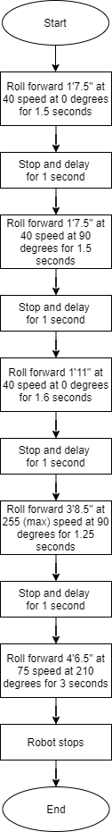

Software
- Sphero Edu App
  - Allows for the creation, development, sharing, and updating of code for the robot
- Block coding
  - Simple commands that the robot follows
  - Block coding is an abstraction of the JavaScript language that is behind the blocks
- GitHub
  - Facilitates collaboration and updates from all team members
- Sphero block code
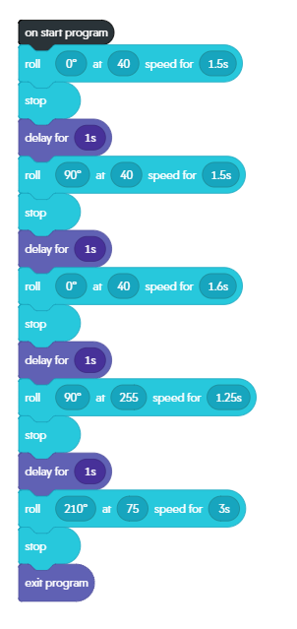
- Sensor data
  - See next pages for robot sensor data

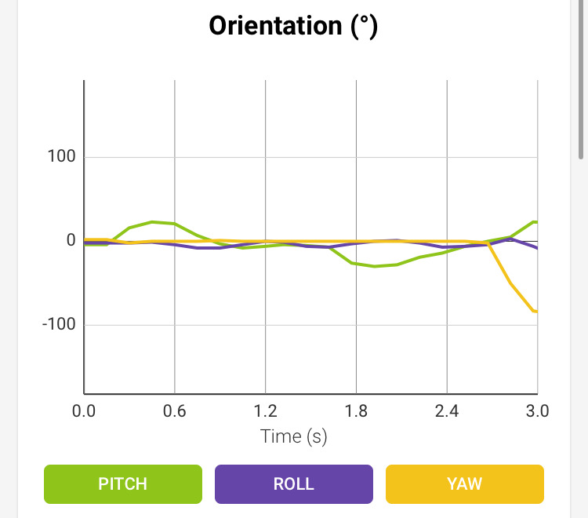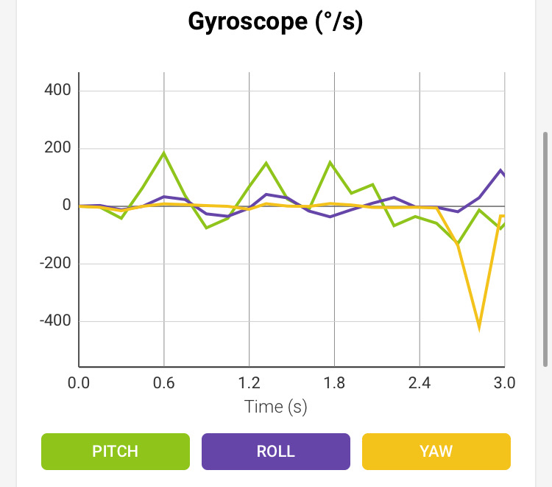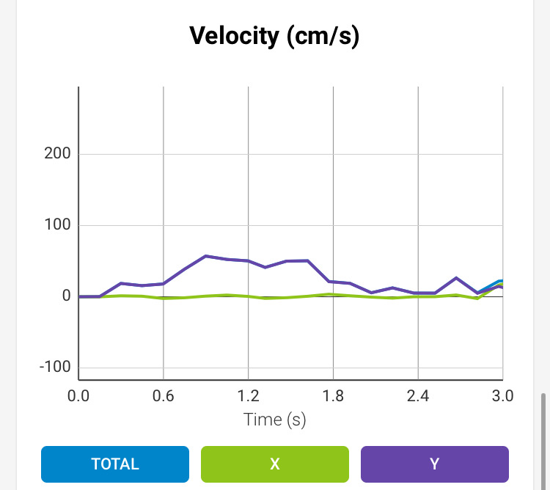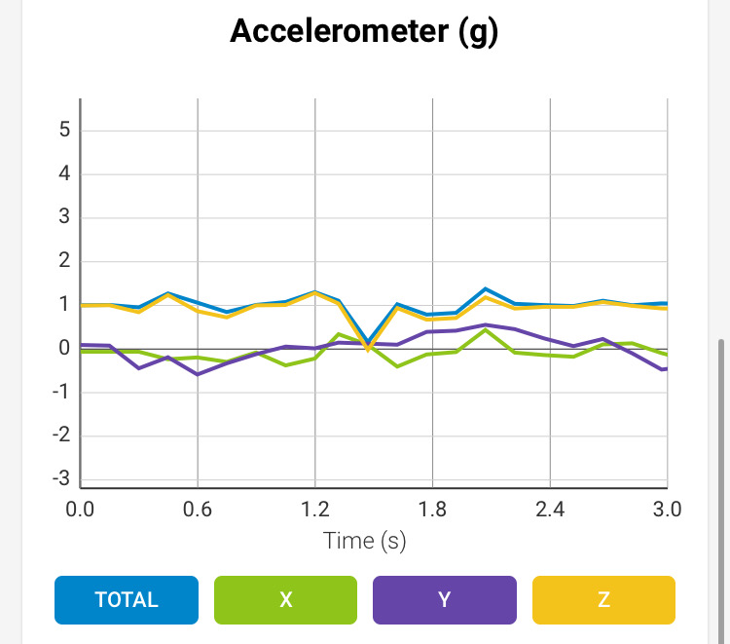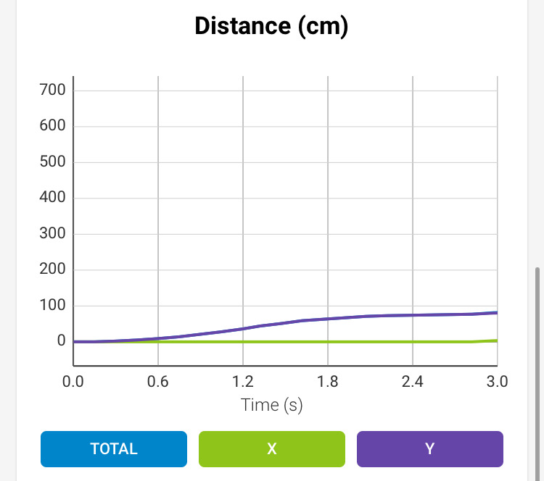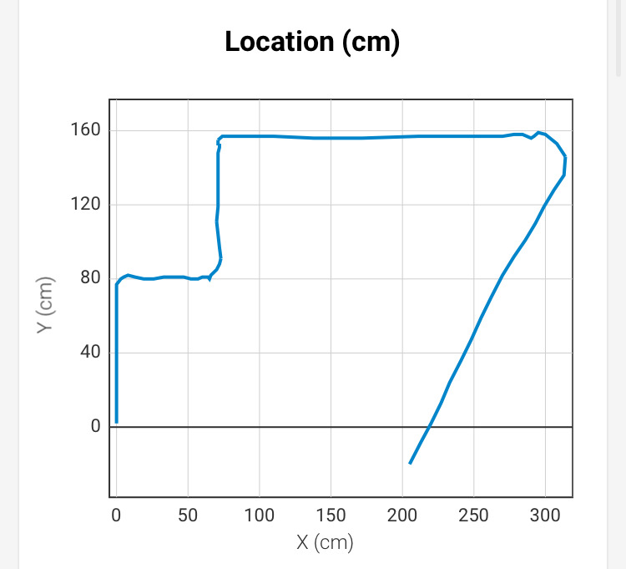

Hardware
- Personal computers running Microsoft Windows 10 and Mac OS developed the application
- An Apple iPhone 6s running iOS 13.3.1 connected to Sphero via Bluetooth tested the application
- A Sphero SPRK+ robot (SK-36FC) borrowed from the Monmouth University Computer Science and Software Engineering Department demonstrated and performed the program

Test Plan

Reason for Test Case | Test Date | Expected Output | Observed Output | Staff Name | Pass/Fail
Verify robot rolls forward 1’7.5” and turns right to avoid and pivot around the 1st obstacle | 12/02/20 | Robot rolls forward 1’7.5” and turns right to avoid and pivot around the 1st obstacle | Robot did not roll far enough and turned too early and hit the 1st obstacle | Joseph F. | Fail
Verify robot rolls forward 1’7.5” and turns right to avoid and pivot around the 1st obstacle after modifying roll time and speed | 12/02/20 | Robot rolls forward 1’7.5” and turns right to avoid and pivot around the 1st obstacle | Robot rolled 1’7.5” and turned right to avoid and pivot around the 1st obstacle | Joseph F. | Pass
Verify robot rolls forward 1’7.5” and turns left to avoid and pivot around the 2nd obstacle | 12/02/20 | Robot rolls forward 1’7.5” and turns left to avoid and pivot around the 2nd obstacle | Robot did not roll far enough and turned too early and hit the 2nd obstacle | Joseph F. | Fail
Verify robot rolls forward 1’7.5” and turns left to avoid and pivot around the 2nd obstacle after modifying roll time and speed | 12/02/20 | Robot rolls forward 1’7.5” and turns left to avoid and pivot around the 2nd obstacle | Robot rolled 1’7.5” and turned left to avoid and pivot around the 2nd obstacle | Joseph F. | Pass
Verify robot rolls forward 1’11” and turns right to avoid and pivot around the 3rd obstacle | 12/02/20 | Robot rolls forward 1’11” and turns right to avoid and pivot around the 3rd obstacle | Robot did not roll far enough and turned too early and hit the 3rd obstacle | Joseph F. | Fail
Verify robot rolls forward 1’11” and turns right to avoid and pivot around the 3rd obstacle after modifying roll time and speed | 12/02/20 | Robot rolls forward 1’11” and turns right to avoid and pivot around the 3rd obstacle | Robot rolled 1’11” and turned right to avoid and pivot around the 3rd obstacle | Joseph F. | Pass
Verify robot rolls forward 3’8.5” and turns right to clear the ramp section | 12/02/20 | Robot rolls forward 3’8.5”, clears the ramp section, and turns right | Robot did not clear the ramp with enough momentum and fell back | Joseph F. | Fail
Verify robot rolls forward 3’8.5” and turns right to clear the ramp section after modifying roll time and speed | 12/02/20 | Robot rolls forward 3’8.5”, clears the ramp section, and turns right | Robot still did not clear the ramp with enough momentum and fell back | Joseph F. | Fail
Verify robot rolls forward 3’8.5” and turns right to clear the ramp section after modifying roll time and speed again | 12/02/20 | Robot rolls forward 3’8.5”, clears the ramp section, and turns right | Robot rolled forward 3’8.5”, going over the ramp, and turned right at the 4th corner | Joseph F. | Pass
Verify robot rolls forward 4’6.5” to knock down as many pins as possible | 12/02/20 | Robot rolls forward 4’6.5” and knocks down 5 pins | Robot did not roll far enough and stopped short of reaching the pins | Joseph F. | Fail
Verify robot rolls forward 4’6.5” to knock down as many pins as possible after modifying roll time and speed | 12/02/20 | Robot rolls forward 4’6.5” and knocks down 5 pins | Robot rolled forward 4’6.5” and knocked down all 5 pins | Joseph F. | Pass
Verify program/robot stops after it passes and knocks down the pins | 12/02/20 | Program/robot stops after it passes and knocks down the pins | Program/robot stopped after it passed and knocked down the pins | Joseph F. | Pass

Task List/Gantt Chart

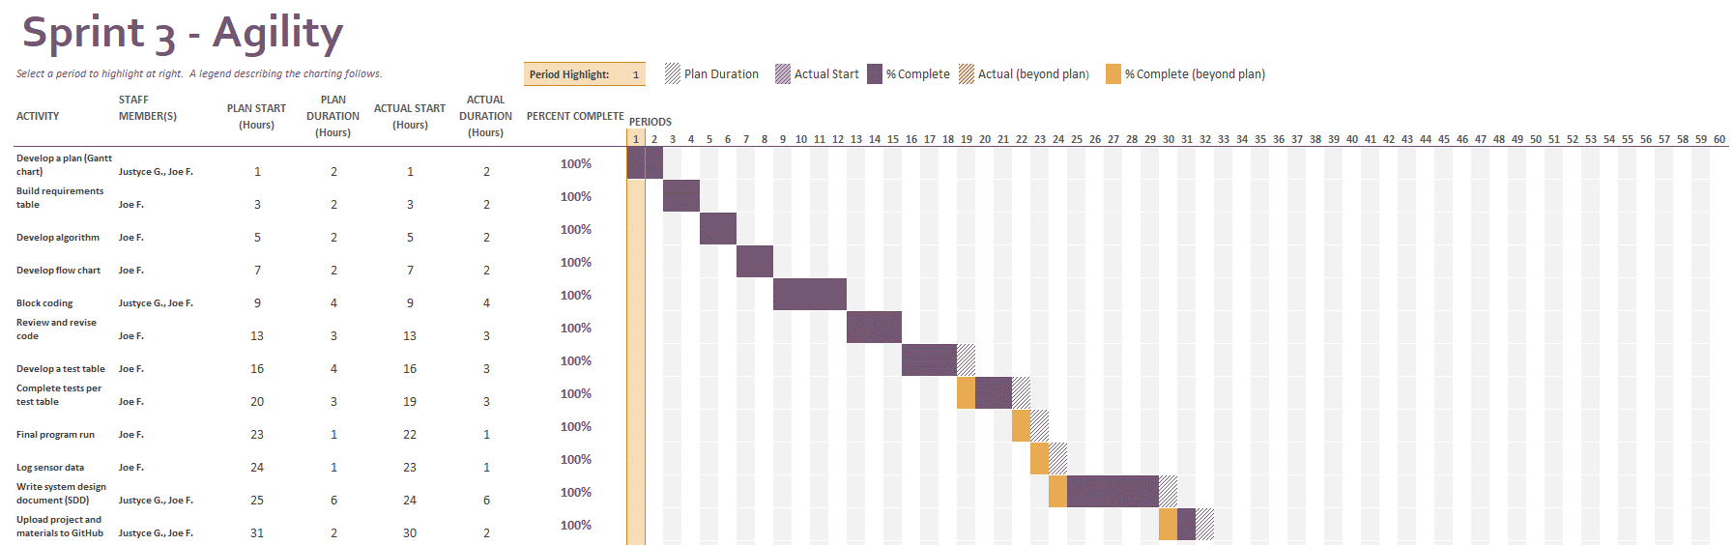

Staffing Plan

Name | Role | Responsibility | Reports To
Joseph Furmanowski | Project Manager,  Programmer | - Oversee project and maintain quality control  - Develop a plan  - Build requirements table  - Develop flow chart  - Write code  - Execute, test, and revise code and algorithm  - Log sensor data  - Write SDD  - Collaborate via GitHub | - Professor Eckert
Justyce Graham | Programmer,  Task Planner | - Develop a plan  - Finalize the Gantt chart and verify that it suits the project  - Contribute to the SDD (Sections 1 and 2)  - Write code  - Collaborate via GitHub | - Professor Eckert  - Project Manager

